 Assignment 2

Name : Sahil Gujarathi
PRN : 1262252760
DIV : 1
Lab Assignment No. : 02

PROBLEM STATEMENT:
Write a menu driven program in C to implement the basic arithmetic operations such as Addition, Subtraction, Multiplication, and Division.

OBJECTIVES:
• To understand the concept of menu driven programming in C.
• To apply conditional statements and switch–case control structures.
• To perform basic arithmetic operations using user-defined input.
• To enhance logical thinking and problem-solving skills.

THEORY:
- if–else ladder statements syntax and sample program
An if–else ladder is used to check multiple conditions sequentially. As soon as one condition is true, its corresponding block of code executes, and the rest are skipped.
Below is the general syntax and a sample program
if (condition1)
{
// code to execute if condition1 is true
}
else if (condition2)
{
// code to execute if condition2 is true
}
else if (condition3)
{
// code to execute if condition3 is true
}
else
{
// code to execute if none of the above conditions are true
}
Example:
Program to find the grade of a student based on their marks:
#include <stdio.h>
int main()
{
int marks;
printf("Enter marks: ");
scanf("%d", &marks);
if (marks >= 90)
{
printf("Grade A");
}
else if (marks >= 75)
{
printf("Grade B");
}
else if (marks >= 50)
{
printf("Grade C");
}
else
{
printf("Fail");
}
return 0;
}
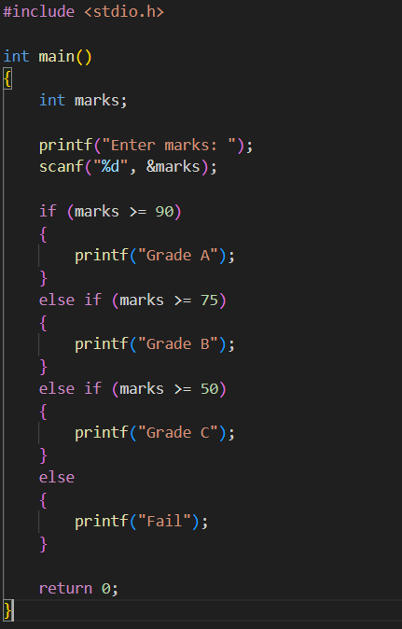

Output:
Enter marks: 91
Grade A
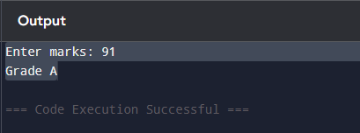
- switch–case or if–else ladder statement syntax and sample program:’
switch (expression)
{
case constant1:
// code
break;

case constant2:
// code
break;

case constant3:
// code
break;

default:
// code if no case matches
}

Sample program:
#include <stdio.h>
int main()
{
int day;
printf("Enter day number (1-7): ");
scanf("%d", &day);

switch (day)
{
case 1:
printf("Sunday");
break;
case 2:
printf("Monday");
break;
case 3:
printf("Tuesday");
break;
case 4:
printf("Wednesday");
break;
case 5:
printf("Thursday");
break;
case 6:
printf("Friday");
break;
case 7:
printf("Saturday");
break;
default:
printf("Invalid day number");
}
return 0;
}
Output:
Enter day number (1-7): 5
Thursday

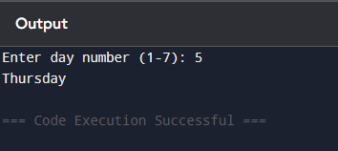
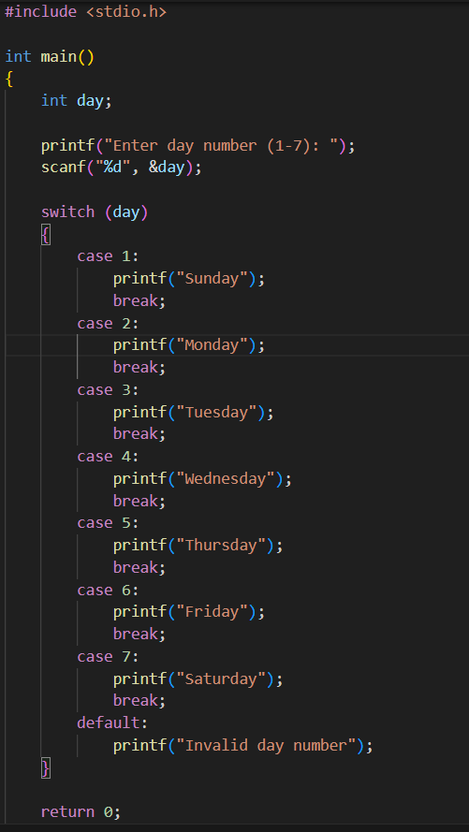

- Basic arithmetic operations include Addition, Subtraction, Multiplication, and Division. Division by zero should be avoided.

ALGORITHM:

Type Program:
#include <stdio.h>

int main() {
float a, b, result;
char operator;

printf("Enter the first number: ");
scanf("%f", &a);

printf("Enter the arithmetic operator (+, -, *, /): ");
scanf(" %c", &operator); // space before %c is IMPORTANT

printf("Enter the second number: ");
scanf("%f", &b);

switch (operator) {
case '+':
result = a + b;
printf("The addition of the numbers is %.2f \n ", result);
break;

case '-':
result = a - b;
printf("The subtraction of the numbers is %.2f \n ", result);
break;

case '*':
result = a * b;
printf("The multiplication of the numbers is %.2f \n", result);
break;

case '/':
if (b == 0) {
printf("Error! Division by zero is not allowed.\n ");
} else {
result = a / b;
printf("The division of the numbers is %.2f \n ", result);
}
break;

default:
printf("Wrong operator!");
}

return 0;
}

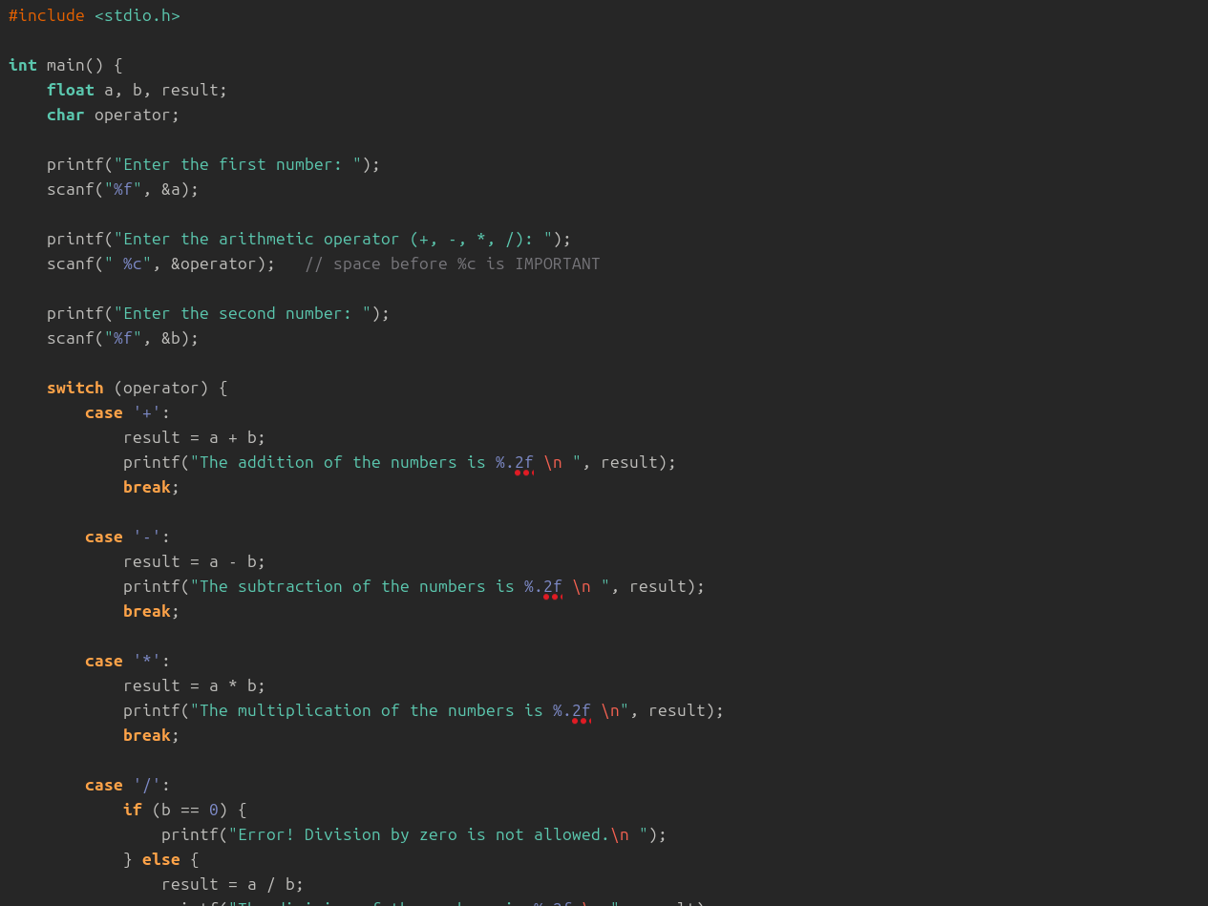
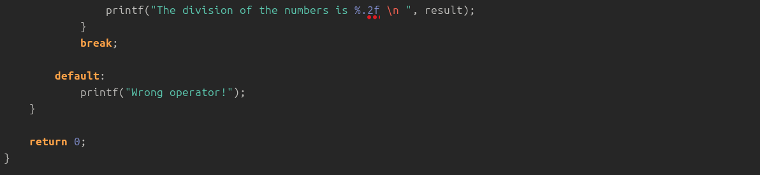

PLATFORM:
Linux

INPUT:
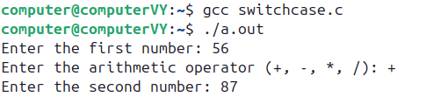

OUTPUT:
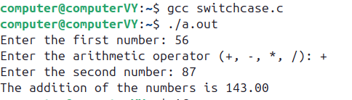

SAMPLE INPUT:
1
10 5

SAMPLE OUTPUT:
Addition = 15

CONCLUSION:
Thus, the menu driven program in C successfully performs basic arithmetic operations using switch–case statements.

FAQs:
1. What is a menu driven program?
2. Why is switch–case preferred over if–else ladder in menu driven programs?
3. What is the purpose of the break statement in switch–case?
4. What is the purpose of the break statement in switch–case?
5. What are the limitations of switch–case compared to if–else?
‘

